**Analysis of Political Voting Patterns and Party Composition**

**DataSet:** <https://data.fivethirtyeight.com/>

**Github Link :**

**Visualization 1:** Line Plot of Votes vs. Agree Percentage by Party

This line plot visualizes the relationship between the number of votes and the agreed percentage for different political parties. Here, we can see the patterns the parties were voted by. The Democrats and Republicans have a high agree percentage, while the Independent has a low percentage.

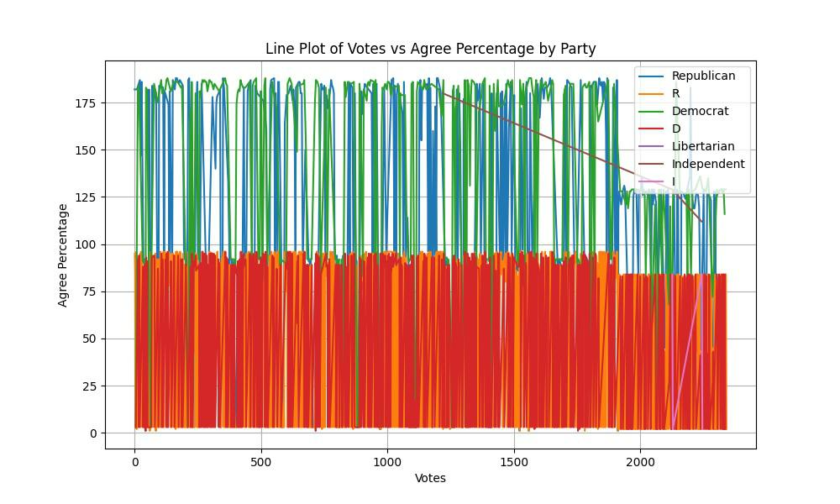

**Visualization 2: Scatter Plot of Votes vs. Agree Percentage with Net Trump Vote Color Mapping**

This scatter plot displays the relationship between the number of votes, the agreed percentage, and the net Trump vote for each data point. We can conclude that Trump has an average number of voters on this.

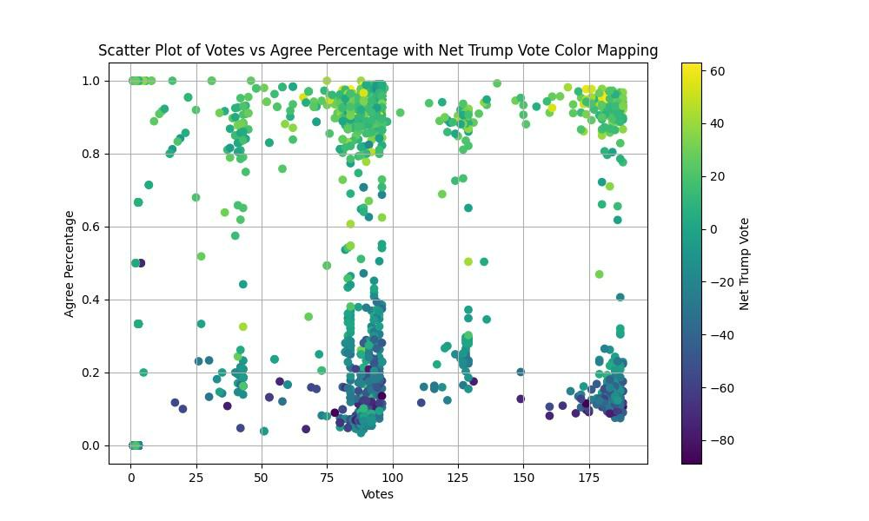

**Visualization 3:** Bar Chart of Party Counts

This bar chart shows the count of representatives for each political party. The Republicans have the highest count of voters, while the Libertarian has the lowest count of voters.

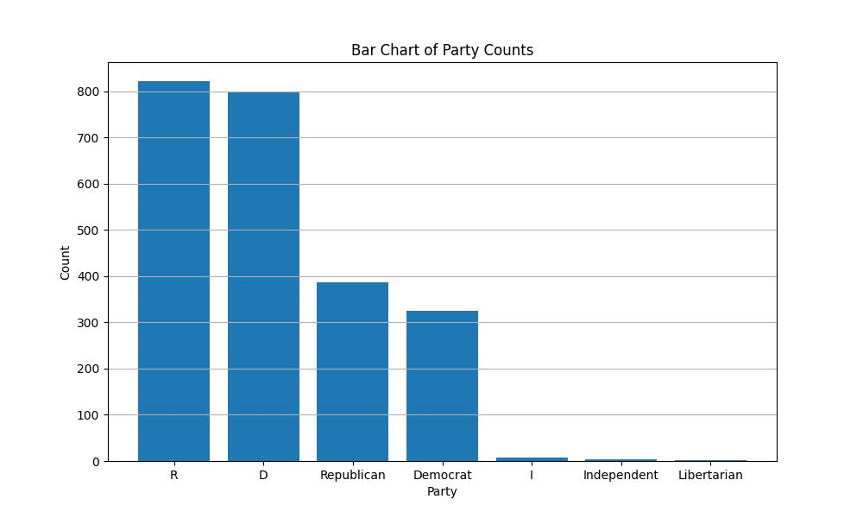

**Visualization 4: Line plot for agree percentage vs predicted percentage:**

This plot shows the agree percentage and predicted agree percentage of votes. From this we can conclude that agree percentage and prediction agree percentage are nearly same.

**References**

<https://data.fivethirtyeight.com/>